BAMAZON NODE.JS APP CUSTOMER PAGE

Our app allows the user to buy products. User is shown a list of products our app has for sale. The list of items is displayed by reading data from the database. The database table that holds the item table is called Products. Along with the item name and price we also store the quantities available for the item and the total sales upto date for that product.

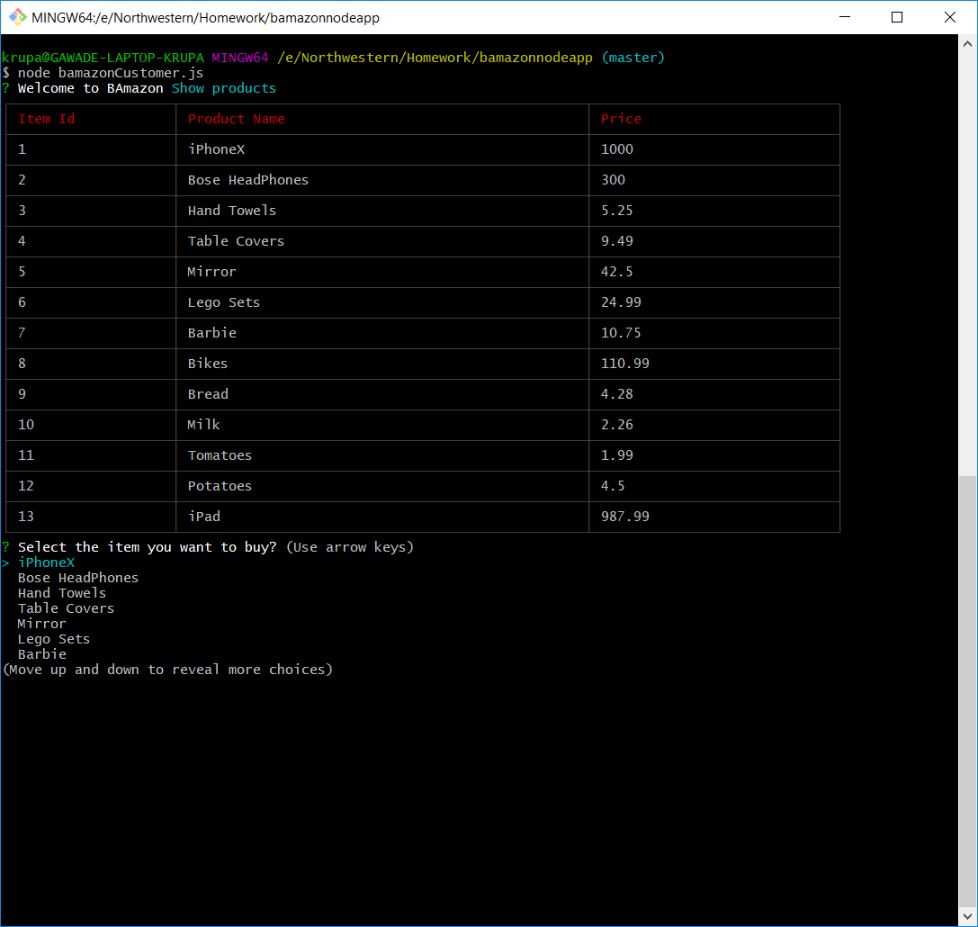

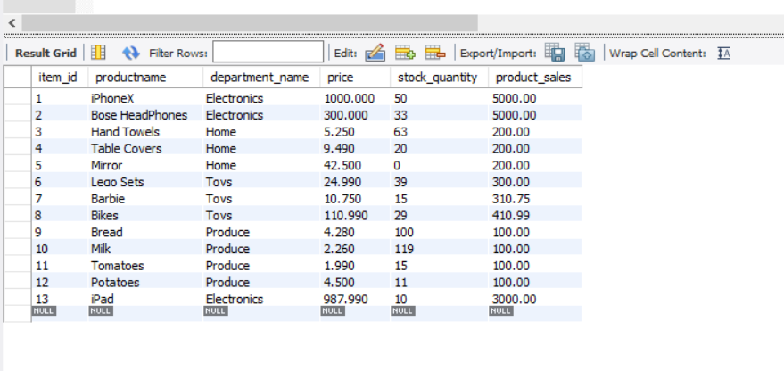

The user can select the item he wants to buy from the list of items. Once he selects his item choice, we will ask for the no. of quantity he wants to order for the item selected. As the user makes a decision, we go to the database to check if we have enough quantities of the user selected item. If we have enough quantities, we place the order and ask him if he wants to order other item. If we do not have enough quantities, we give a error message saying we don’t have enough quantity for the item. 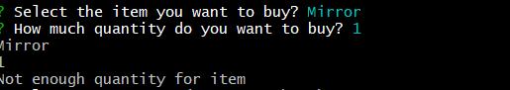



User selects to buy Table Covers and enters quantity 10. App will go to database and check if we have enough quantities available. Since we have sufficient quantities, the stock quantity will be reduced by 10 and the product_sales will be updated with the new sale number.





User can order multiple item and exit whenever he is done.

BAMAZON MANAGER APP

BAmazon Manager App allows the manager of the store to view products for sale, Low Inventory, Add Inventory and Add New Products. When the manager app is run, we show the manager a list of operations he can perform.

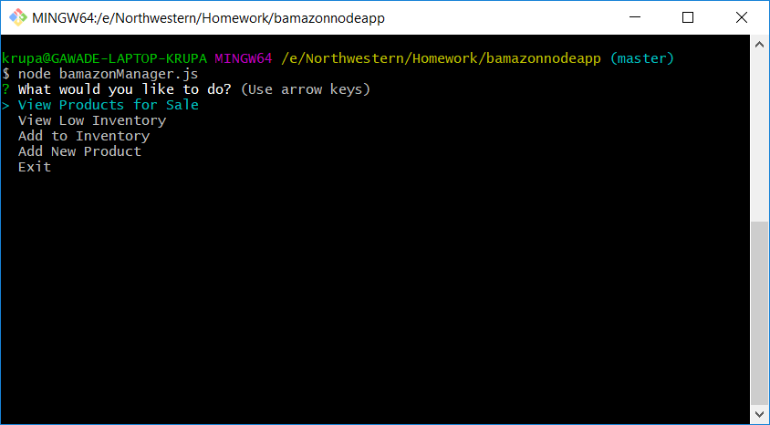

When he selects View Products for Sale, we display all the products from the database along with their price and Stock Quantity

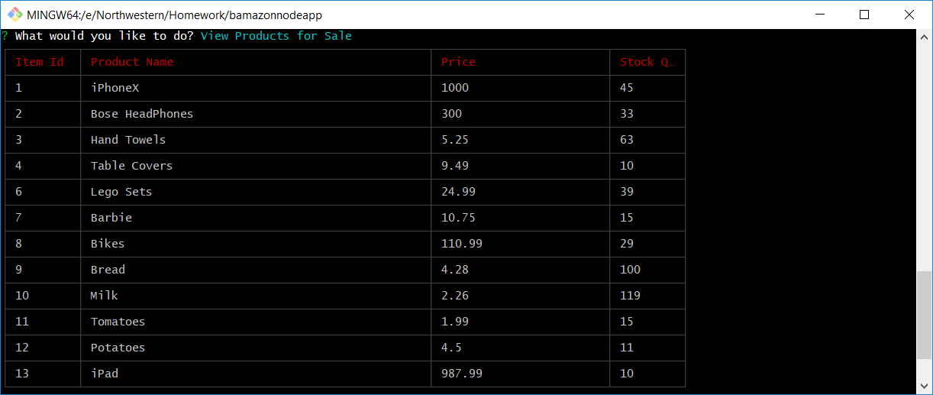

When the manager wants to view the products that have low inventory, less than or equal to 5, he can select View Low Inventory

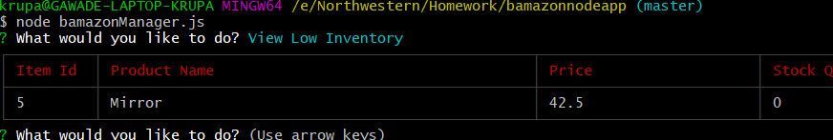

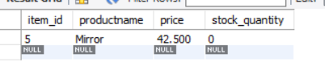

Manager can add Stock Quantities to Existing Item by selecting option Add Inventory. He can select the item_id and input the quantity he wants to add the Stock.

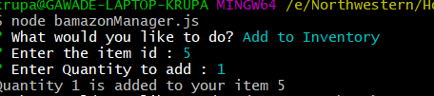

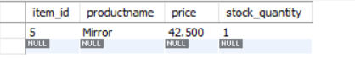

Manager can add a new product to his existing list of products by selecting Add New Product. The App would ask him details about the new product and display a Success message once its added to database

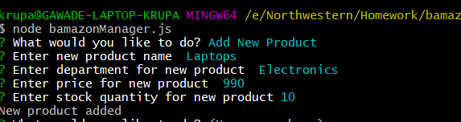

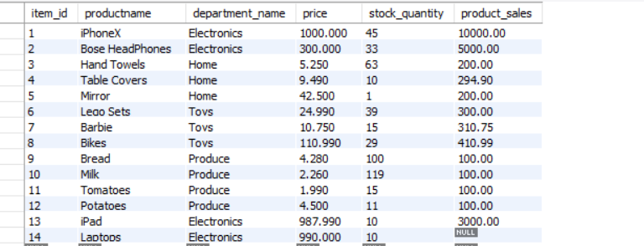

Manager can exit once he finishes all the tasks he wanted to complete for the day.

BAMAZON SUPERVISOR APP

BAmazon Supervisor App helps the supervisor to get the overall picture about the sales across different departments. We combine two database tables to get detailed information about each department sales. One table holds the data about the products in different department and the other table holds the data about the overhead cost for each department.

Supervisor selects View Product Sales by Department

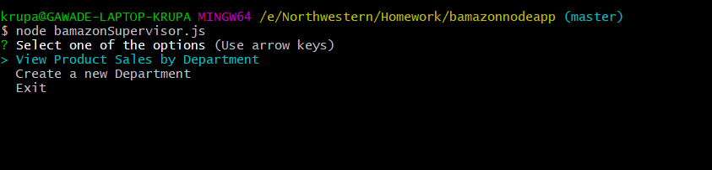

When the supervisor, selects this option, combine data from two database and run a query which looks like below:

select department_id, departments.department_name, departments.over_head_cost,

IFNULL(sum(products.product_sales), 0) as sales, (IFNULL(sum(products.product_sales),0) - departments.over_head_cost) as total_profit

from products RIGHT JOIN departments

ON products.department_name = departments.department_name

group by departments.department_name

order by departments.department_id;`;

We select department id, department name and overhead cost from departments table. Check for null value in product_sales field in products table and replace with 0 and alias it as sales. To get the total profit for a department, we deduct the product_sales with over head cost for each department we join the two tables with department names and group by department names. To view the table in sequential order we order by department id.

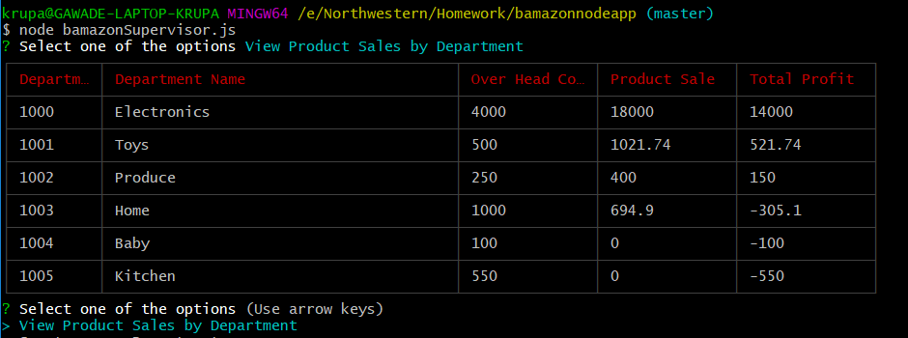

When the supervisor selects Create a new Department. He has to input the name for the new department and input the over head cost for the new department.

